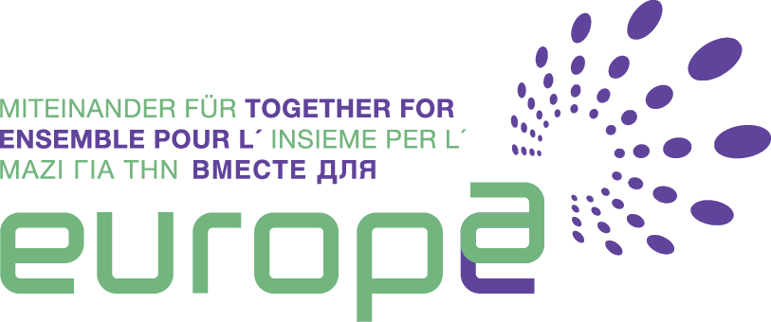
Hon. David Maria Sassoli, Member of the European Parliament, Italy, during the Ecumenical Prayer Celebration in Rome 24th March 2017

Honourable Sassoli, on the eve of the 60th anniversary of the Treaties of Rome, which marks the beginning of the European Union, many point out that Europe has lost its Christian roots, placing too much emphasis perhaps on finance, bureaucracy and national interests, incapable of showing solidarity and welcome, or encouraging development focused on the human person. What are your thoughts?

“It is important that Christians make themselves heard more, there should be networks among Christians which would provide a witness and example to others. There is no doubt, values such as peace, co-existence, solidarity and justice, which are of Christian origin, are today also considered as paradigms of political, cultural and moral commitment by citizens who are not themselves Christian. These are the key values that constitute European identity: something Christians ought to be happy with, because within what is considered the European identity, as such, are these precisely Christian values. What needs to be done now is to explain everything well to European citizens. Currently the idea of Europe frightens and makes people anxious. It appears burdensome, instead we need to show the value of unity to the peoples of Europe. What is also at stake here, the challenge for this Century, is to shape a global market. Globalisation without rules leads to marginalisation, poverty and misery, and environmental catastrophes. The great challenge Europe continues to face is to give rules and values to the world. Market rules which do not successfully safeguard human rights, freedom and democracy would be merely economic allowing the stronger to win, and this is not what we want. So, the challenge is this: Christian values which are at the basis of European identity today must provide the key elements to face this great global challenge”.
In the context of overcoming the divisions between countries that are economically more or less developed, we often speak about a “two-tier Europe”, what is your view on this?
“If this means that there would be countries of class A and class B, then that is wrong. Instead, if it means that non-member countries can collaborate, under the ‘closer cooperation’ provision of the Lisbon Treaty, in the context of joint policies, without upsetting EU standards, then it could be interesting. This is how the euro was introduced – with a closer cooperation starting from ten, eleven countries and others joined in later. Because within EU mechanisms it is effectively difficult to achieve unanimity. If there were countries such as France, Italy, Spain, Germany, Belgium and others which were to opt for a common defence solution, that would be great: we would have a core which would lead the way that others might follow”.

There has been much discussion about the necessity to review the Treaties. It was underlined also by Pope Francis in his speech at the European Parliament in May 2016, on the occasion of the Conferral of Charlemagne Prize. In what way do you believe they need to be modified?
“They should be changed, I would be in favour of arriving eventually at a European Constitution, but realistically and with regret I need to say that currently it might be very dangerous to re-open a discussion on the Treaties, so one needs to be very careful. Who knows what the outcome would be for Europe if we reopened the debate on Schengen with the current nationalist governments afraid of the influx of immigrants? It is better to focus on those policies which can contribute to developing Europe, because beyond institutions, rules and treaties, that is what is now needed most of all”.
Claudia Di Lorenzi

